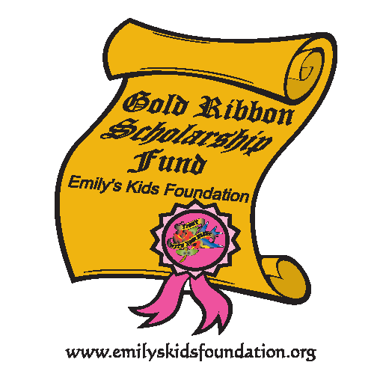Gold Ribbon Scholarship
Emily’s Kids Foundation Inc.
Eligibility Requirements

Applicants must be:

-A child who has cancer under the age of 25 and diagnosed before the age of 18 with hematology or oncology issues.

-A citizen of the United States living within the country and attending school in the U.S. and have been treated at one of the following locations.

-Brenner Children’s Hospital, Winston-Salem, NC.
-Duke Children’s Hospital, Durham, NC.
-Hemby Children’s Hospital, Charlotte, NC
-James and Connie Maynard Children’s Hospital at Vidant Medical Center
Greenville, NC.
-Levine Children’s Hospital, Charlotte, NC.
-Mission Children’s Hospital, Asheville, NC.
-North Carolina Children’s Hospital at UNC, Chapel Hill, NC.

Evaluation Criteria - This is a competitive application and all requirements carry weight in the review process. Not all applicants will receive a scholarship.

Applications Must Include the Following for Consideration-Physicians/Social Worker verification form.

Gold Ribbon Scholarship Expectations -Recipients of a Gold Ribbon Scholarship agree to become an ambassador for Emily’s Kids Foundation. Ambassadors are individuals who are passionate about pediatric cancer survivorship and are expected to raise awareness about the issues related to pediatric cancer/survivorship.

Scholarship Renewals-Scholarship recipients under the age of 25 are eligible for a maximum of four scholarships. Renewal applicants must apply each year and scholarships are neither automatic nor guaranteed.

Scholarship Fund Disbursement -The scholarship award will be paid in a lump sum amount to the families of the recipients for the purpose of defraying tuition and additional fees or books. Any unused funds are to be returned to Emily’s Kids Foundation.

